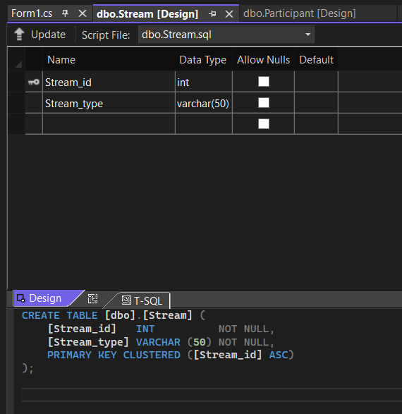

**Table -1 ^**

**Table – 2 :**

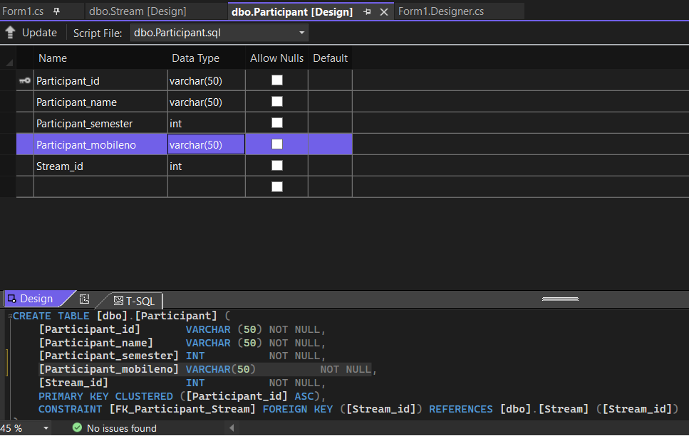

**Form design**

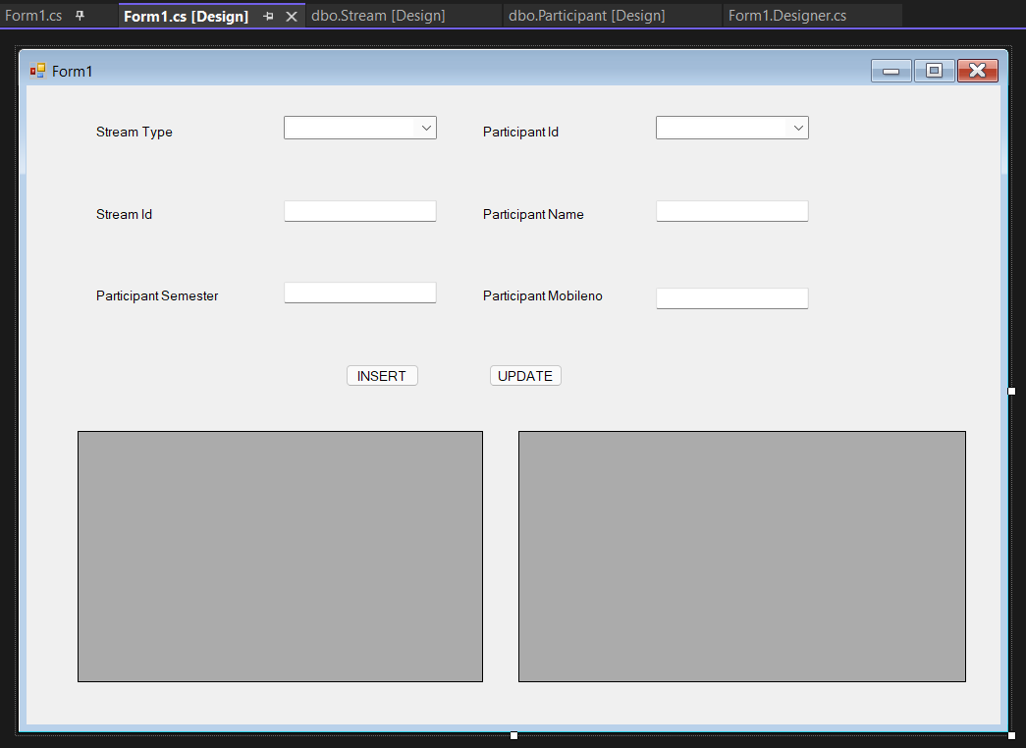

**code**

using System;

using System.Collections.Generic;

using System.ComponentModel;

using System.Data;

using System.Data.SqlClient;

using System.Drawing;

using System.Linq;

using System.Text;

using System.Threading.Tasks;

using System.Windows.Forms;

namespace SET_IV

{

public partial class Form1 : Form

{

public Form1()

{

InitializeComponent();

cfill();

sfill();

}

public void cfill()

{

cmb_pi.Items.Clear();

SqlConnection con = new SqlConnection(@"Data Source=(LocalDB)\MSSQLLocalDB;AttachDbFilename=C:\Users\pares\OneDrive\Documents\new.mdf;Integrated Security=True;Connect Timeout=30");

string q = "select * from Participant ";

SqlCommand cmd = new SqlCommand(q, con);

try

{

con.Open();

SqlDataReader dr = cmd.ExecuteReader();

while(dr.Read())

{

string Stream_type = dr.GetString(0);

cmb_pi.Items.Add(Stream_type);

}

}

catch(SqlException excep)

{

MessageBox.Show(excep.Message);

}

con.Close();

}

public void sfill()

{

cmb_st.Items.Clear();

SqlConnection con = new SqlConnection(@"Data Source=(LocalDB)\MSSQLLocalDB;AttachDbFilename=C:\Users\pares\OneDrive\Documents\new.mdf;Integrated Security=True;Connect Timeout=30");

string q = "select * from Stream ";

SqlCommand cmd = new SqlCommand(q, con);

try

{

con.Open();

SqlDataReader dr = cmd.ExecuteReader();

while (dr.Read())

{

string Participant_id = dr.GetString(1);

cmb_st.Items.Add(Participant_id);

}

}

catch (SqlException excep)

{

MessageBox.Show(excep.Message);

}

con.Close();

}

public void disp_Stream()

{

SqlConnection con = new SqlConnection(@"Data Source=(LocalDB)\MSSQLLocalDB;AttachDbFilename=C:\Users\pares\OneDrive\Documents\new.mdf;Integrated Security=True;Connect Timeout=30");

con.Open();

SqlCommand cmd = con.CreateCommand();

cmd.CommandType = CommandType.Text;

cmd.CommandText = "select * from Stream";

DataTable dt = new DataTable();

SqlDataAdapter da = new SqlDataAdapter(cmd);

da.Fill(dt);

dgv1.DataSource = dt;

con.Close();

}

public void disp_Participant()

{

SqlConnection con = new SqlConnection(@"Data Source=(LocalDB)\MSSQLLocalDB;AttachDbFilename=C:\Users\pares\OneDrive\Documents\new.mdf;Integrated Security=True;Connect Timeout=30");

con.Open();

SqlCommand cmd = con.CreateCommand();

cmd.CommandType = CommandType.Text;

cmd.CommandText = "select * from Participant";

DataTable dt = new DataTable();

SqlDataAdapter da = new SqlDataAdapter(cmd);

da.Fill(dt);

dgv2.DataSource = dt;

con.Close();

}

private void btn_insert_Click(object sender, EventArgs e)

{

SqlConnection con = new SqlConnection(@"Data Source=(LocalDB)\MSSQLLocalDB;AttachDbFilename=C:\Users\pares\OneDrive\Documents\new.mdf;Integrated Security=True;Connect Timeout=30");

con.Open();

try

{

string str = "insert into Participant(Participant_id,Participant_name,Participant_semester,Participant_mobileno,Stream_id)values('" + cmb_pi.Text + "','" + txt_pn.Text + "' ,'" + txt_ps.Text + "' ,'" + txt_pm.Text + "' ,'" + txt_si.Text + "' ) ;";

SqlCommand cmd = new SqlCommand(str, con);

cmd.ExecuteNonQuery();

string str1 = "select max(Participant_id) from Participant; ";

SqlCommand cmd1 = new SqlCommand(str1, con);

SqlDataReader dr = cmd1.ExecuteReader();

if(dr.Read())

{

MessageBox.Show("Data saved successfully.");

txt_pn.Text = "";

txt_ps.Text = "";

txt_pm.Text = "";

txt_si.Text = "";

cmb_pi.Text = "";

}

}

catch(SqlException excep)

{

MessageBox.Show(excep.Message);

}

con.Close();

cfill();

sfill();

disp_Stream();

disp_Participant();

}

private void cmb_st_SelectedIndexChanged(object sender, EventArgs e)

{

SqlConnection con = new SqlConnection(@"Data Source=(LocalDB)\MSSQLLocalDB;AttachDbFilename=C:\Users\pares\OneDrive\Documents\new.mdf;Integrated Security=True;Connect Timeout=30");

string q = "select * from Stream where Stream_type='" + cmb_st.Text + "';";

SqlCommand cmd = new SqlCommand(q, con);

try

{

con.Open();

SqlDataReader dr = cmd.ExecuteReader();

while (dr.Read())

{

string Stream_id = dr.GetInt32(0).ToString();

txt_si.Text = Stream_id;

}

}

catch (SqlException excep)

{

MessageBox.Show(excep.Message);

}

con.Close();

}

private void cmb_pi_SelectedIndexChanged(object sender, EventArgs e)

{

SqlConnection con = new SqlConnection(@"Data Source=(LocalDB)\MSSQLLocalDB;AttachDbFilename=C:\Users\pares\OneDrive\Documents\new.mdf;Integrated Security=True;Connect Timeout=30");

string q = "select * from Participant where Participant_id ='" + cmb_pi.Text+ "';";

SqlCommand cmd = new SqlCommand(q, con);

try

{

con.Open();

SqlDataReader dr = cmd.ExecuteReader();

while(dr.Read())

{

string Participant_name = dr.GetString(1);

string Participant_semester=dr.GetInt32(2).ToString();

string Participant_mobileno = dr.GetString(3);

txt_pn.Text = Participant_name;

txt_ps.Text = Participant_semester;

txt_pm.Text = Participant_mobileno;

}

}

catch(SqlException excep)

{

MessageBox.Show(excep.Message);

}

con.Close();

}

private void btn_update_Click(object sender, EventArgs e)

{

SqlConnection con = new SqlConnection(@"Data Source=(LocalDB)\MSSQLLocalDB;AttachDbFilename=C:\Users\pares\OneDrive\Documents\new.mdf;Integrated Security=True;Connect Timeout=30");

string query = ("update Stream set Stream_id=@Stream_id,Stream_type=@Stream_type where Stream_id=@Stream_id");

SqlCommand cmd = new SqlCommand(query, con);

cmd.Parameters.AddWithValue("@Stream_id", txt_si.Text);

cmd.Parameters.AddWithValue("@Stream_type", cmb_st.Text);

try

{

con.Open();

int i = cmd.ExecuteNonQuery();

if (i > 0)

MessageBox.Show("Data is updated");

else

MessageBox.Show("Data not found");

}

catch (SqlException excep)

{

MessageBox.Show(excep.Message);

}

con.Close();

cfill();

sfill();

disp_Stream();

disp_Participant();

}

}

}